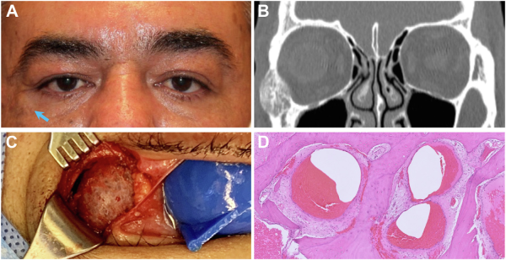

A healthy 52-year-old man presented with a painless, enlarging, right lateral orbital nodule of 1-year duration (A, arrow). Clinicalexamination revealed a 2.3-cm firm immobile lateral orbital rim mass. Computed tomography displayed an expansile and osteolyticneoplasm of the zygoma with orbital and extraorbital extension (B). Lateral orbitotomy exposed a porous neoplasm of the anteriorzygomatic face (C). The exophytic component was resected, and histopathological examination demonstrated multiple, dilated, blood-filledcavities between bony trabeculae (D). Based on the provided images and clinical description please make an ophthalmic diagnosis for this patient. And output the diagnostic conclusions only

**Aneurysmal bone cyst**